The History of Sligh
Dave Meddish
For a substantial portion of the last six years, Sligh decks have been highly notable. From the earliest Pro Tour qualifiers to the current Standard environment, they has been played and played extremely successfully. Sligh remains one of the most enduring and malleable deck archetypes in Magic, ever.

The First Sligh
Sligh was the brainchild of one of the great deckbuilders in Magic history, Jay Schneider. Jay built the first Sligh deck in the summer of 1994, partly to find a deck capable of beating a mono-blue ancestor of Draw-Go that fellow playtester Paul Sligh had created. For two years, Sligh was dominant in every Atlanta-area tournament, although it was then known as "Geeba," from an RPG term for the Goblin language, which was one word: "geeba!"
Then it came to the qualifier circut.
Paul Sligh's Orcish Librarian Deck, 1996
Main Deck |  | Sideboard
2 Dragon Whelp  2 Brothers of Fire  2 Orcish Artillery  2 Orcish Cannoneers  4 Ironclaw Orcs  3 Dwarven Lieutenant  2 Orcish Librarian  4 Brass Man  2 Dwarven Trader  2 Goblin of the Flarg | 1 Black Vise  1 Shatter  1 Detonate  4 Lightning Bolt  4 Incinerate  1 Fireball  1 Immolation  4 Strip Mine  4 Mishra's Factory  2 Dwarven Ruins  13 Mountain | 1 Shatter  1 Detonate  1 Fireball  1 Meekstone  1 Zuran Orb  3 Active Volcano  2 Serrated Arrows  1 An-Zerrin Ruins  4 Manabarbs

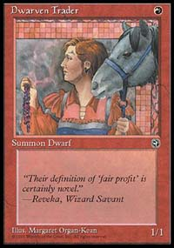
Sligh is famous for its suboptimal cards
In case you're wondering why there are sub-optimal cards such as Dwarven Trader (which obviously interacts poorly with Goblins of the Flarg) in the deck, this cycle of qualifiers were being run under the "five cards from each expansion" rule, meaning that you had to have a minimum of five cards from each Standard-legal expansion in play at the time. This included Fallen Empires, Chronicles and Homelands.
Finding five good Homelands cards for a tournament deck is no easy task.
The deck obviously functioned quite well, though, given the success it had. Not a typical red burn deck, it was more of an aggressive control deck. At the time, when you talked about a control deck, you were most likely talking about blue or white deck. Not Sligh. Most of the direct damage was aimed at clearing the path for a small but aggressive creature base.
The deck was successful on the PTQ circut, but that alone does not explain how it exploded on the Magic scene. In actuality, there were several factors that led to it becoming one of the most popular and enduring decks of all time:
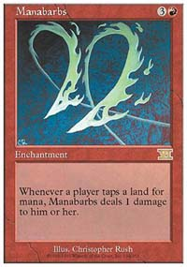
CoP: Red was a nightmare
- This was the time that the Internet and Magic started to come together. In 1996, The Dojo, the first of the Magic-related websites, was not yet in full swing, so Usenet newsgroups and The Duelist were the only sources of Magic tournament information. Fatefully, once of the first actual "tournament reports" came out of that Atlanta PTQ from David Doust of New Wave, which printed the decklist of this very curious, very unusual mono-red deck that performed far better than the author of that report believed possible.
- The deck was cheap and easy to build, consisting mostly of commons and uncommons and a few "chaff" rares normally found in the backs of trade binders. The most expensive card in the deck was Manabarbs, which were very easy to purchase or trade for. Under the old Fourth Edition rules, Manabarbs completely shut down Circle of Protection: Red.
- It consistently beat Necro. This was when Necropotence was beginning its reign, and out of nowhere came this janky deck that could consistently beat it, something few other decks could accomplish.

So What Makes It Tick?
The classic Sligh deck is distinguishable from your normal mono-red burn deck by the concept of the mana curve, at the time an unheard-of term. Jay first came up with the concept, then built the deck around his idea, realizing that the best decks would not be based on a single card but on a group of cards. The Sligh deck wants to be able to play a land and be able to use all its mana available on that turn, moving up in casting cost progressively. This means the deck contains more one- and two-drops than three- and four-drops.
Examine a typical Type II Sligh deck from 1996, not forced to put in truly suboptimal Homelands cards:
1996 Type II Sligh
Main Deck |  | Sideboard
2 Gorilla Shaman  3 Ironclaw Orcs  2 Orcish Librarian  3 Dwarven Soldier  2 Brothers of Fire  4 Orcish Artillery  2 Storm Shaman  1 Sabretooth Tiger  2 Dragon Whelp | 4 Incinerate  1 Immolation  1 Shatter  1 Detonate  4 Brass Man  1 Black Vise  4 Strip Mine  4 Mishra's Factory  2 Dwarven Ruins  13 Mountain | 4 Manabarbs  2 Serrated Arrows  1 Shatter  1 Detonate  1 Fireball  1 Meekstone  1 Zuran Orb  3 Active Volcano  1 An-Zerrin Ruins

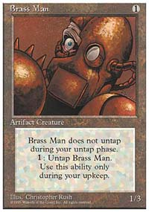
An unusual choice - but a wise one
Counting the sideboard, the mana curve looks like this:
1cc: 9-13
2cc: 6-8
3cc: 3-4
4cc: 2-3
Xcc: 1-3
Burn: 8-12
Given this ratio, you were almost guaranteed to be able to play threats in a progressive order starting with turn one. It was this maximization of mana that gave the deck its ability to apply constant pressure on an opponent.
Sligh decks are also noted for containing creatures that have a high power-to-casting-cost ratio but with some sort of drawback. The first Sligh deck had Brass Men, a powerful 1/3 for only 1 generic mana, but cost 1 to untap. To the Sligh deck, the drawback is negligible. Ironclaw Orcs were a mainstay of Sligh in the early days, being a 2/2 for only 1R, the drawback being that they could block no creature of power greater that 1. Since the Ironclaw Orcs only purpose was to be an offensive weapon, they seldom were ever used to block, and hence their drawback isn't a drawback at all.
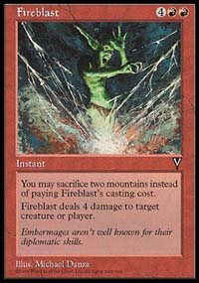
One of the most potent finishers in Magic
The Brothers of Fire, Cannoneers and Artillery have a hefty cost of dealing damage to their controllers, but again, to the Sligh deck the effect is negligible. With these creatures clearing the way for the attacking forces, the Sligh player would deal twenty damage to an opponent long before it would deal twenty damage to himself.

Speed Kills
With the release of Mirage and Tempest blocks, the Standard environment sped up considerably Sligh changed from a red control deck to a pure beatdown deck. David Price, the "King of Beatdown," is credited with the "Deadguy Red" variant of Sligh that was easily capable of turn four kills, evolving from his Tempest-block deck that won PT-Los Angeles '98. During the time Tempest and Mirage blocks were Standard-legal, this beatdown variant of Sligh was among the most consistent decks in the Type II environment.
Deadguy Red
Main Deck |  | Sideboard
4 Mogg Fanatic  4 Jackal Pup  3 Mogg Conscripts  4 Ironclaw Orcs  4 Fireslinger  4 Ball Lightning | 4 Incinerate  4 Fireblast  4 Shock  4 Cursed Scroll  17 Mountain  4 Wasteland | 2 Dwarven Miner  1 Dwarven Thaumaturgist  1 Orgg  4 Pyroblast  4 Ankh of Mishra  2 Phyrexian Furnace  1 Torture Chamber

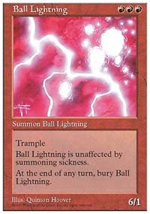
An optimal turn three play
The deck follows the classic Sligh mana curve, up to a point. It has several powerful one-drops fitting the typical undercosted aggressive red creatures, like Mogg Conscripts, Fireslingers and Jackal Pups, and the powerhouse Ball Lightning in the 3cc slot. The deck really doesn't need anything four the four slot. By the time Deadguy Red gets to four mana, it should be capable of burning an opponent out. Turn four kills are extremely common with this deck.
When Mirage block rotated out, taking the dreaded Fireblast out of Standard, the deck slowed down but was still a force to be reckoned with. Mogg Flunkies and Goblin Lackeys were added to fill out the creature component and it became less of a burn-out deck and more of a beatdown deck. Still fast, still deadly, and with the power of the broken Cursed Scroll, more than capable of delivering a quick death. Turn four kills were a thing of the past, but turn five and six kills were still possible.

A Blast From The Past
Once Tempest block disappeared from Standard, Sligh decks seemed to have vanished with them. But now Sligh is back, with another new Standard version that is more aggressive than the original archetype but has more control than Deadguy Red. The "grandfather of Sligh," Jay Schneider, created this latest version:
Brawler-Sligh
Main Deck |  | Sideboard
4 Goblin Cadets  4 Goblin Patrol  4 Veteran Brawlers  2 Spur Grappler  2 Keldon Vandals  3 Keldon Champion  4 Tangle Wire | 4 Shock  4 Seal of Fire  4 Rhystic Lightning  3 Hammer of Bogardan  4 Rishadan Port  4 Ghitu Encampment  14 Mountain | 4 Thran Foundry  4 Earthquake  3 Mogg Salvage  2 Boil  2 Scald

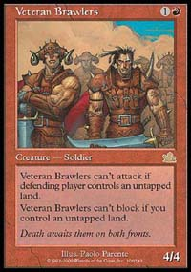
An optimal turn three play
You see how the deck is built like a classic Sligh deck. It contains aggressive one- and two-casting cost creatures that have a negligible drawback, like the Brawlers and Goblins. The mana curve for the deck is a little funky-it has plenty of good 1cc drops but only the Veteran Brawlers fill the two-slot, although the Ghitu Encampment, Jay says, can be considered a two-drop of sorts. Aside from that, it fits the Sligh mana curve perfectly.
There is excellent synergy between the Ports, Tangle Wire and Veteran Brawlers. A turn two Brawler followed by a turn three Tangle Wire is good for at least eight points of damage with the Brawler. At the very worst, the Brawler makes for a Stone Rain and a 4/4 wall. At best, he ends the game by turn four, usually backed up by a Spur Grappler or Keldon Champion.
The post-Invasion version of the deck will still be viable. The deck doesn't lose a lot from the Urza's block: the 2/1 Goblins (Patrol and Cadets), Keldon Champion and Ghitu Encampment. The Keldon Vandals that currently fill the deck are in primarily as defense against Turbo-Tinker can easily be replaced by two more Spur Grapplers.
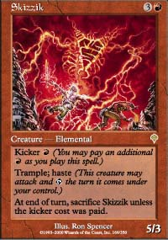
Skizzik acts like Ball Lightning in red decks
The Skizzik is a perfect replacement for the Champions, but the deck loses the powerful 2/1 creatures in the one slot. The best replacements for them in the current environment would be Raging Goblin and perhaps Kris Mage. This will slow the deck down, but in a Standard environment consisting of Mercadian and Invasion blocks, everything is going to be much slower and the loss of speed is not going to be fatal. The deck may have to pack Rath's Edge main deck and Cursed Totems in the sideboard to deal with what will no doubt be the bane of mono-red in the new Standard; Crimson Acolyte.

Just One More Thing...
So just one question remains. Why, if Jay Schneider designed the deck, is it called "Sligh?"
As Jay himself tells it, he and his wife were scheduled to go to on vacation the weekend of the Pro Tour Qualifier in Atlanta, so he gave the "Geeba" deck to Paul Sligh.
Paul went on to perform extremely well at the PTQ, and tournament reports and players outside of the Atlanta area caught on to the power of the deck, which came to be named "Sligh" after the man who played it, not the man who designed it.
History is filled with such coincidences, and this is one of the more colorful ones in the pantheon of Magic.
Thanks to Jay Schneider and The Sligh-brary for their assistance.

